Day 387 — EDA & Data Preprocessing
Complete Revision Notes | EDA Workflow • Data Cleaning • Outliers • Feature Engineering • Scaling
Learning goal: perform a complete Exploratory Data Analysis (EDA) and data preprocessing workflow in Python: understand dataset structure, clean missing and duplicate records, detect and treat outliers, analyze distributions and skewness, examine correlations, engineer meaningful features, and apply normalization and standardization without data leakage.

1. What is Exploratory Data Analysis (EDA) & Data Preprocessing?
Exploratory Data Analysis (EDA) is the systematic process of inspecting, summarizing, and visualizing a dataset to discover patterns, spot anomalies, test assumptions, and verify data quality before building predictive models.
Data preprocessing transforms raw, noisy, and inconsistent observations into a clean, structured, and numerical representation suitable for statistical analysis and machine learning algorithms.
Workflow Stage | What it helps us do | Example Action
Understand dataset | Inspect shape, column types, memory usage and sample rows | Check df.info() and df.describe()
Clean data | Fix missing values, remove duplicates and repair data types | Impute missing salary with median
Detect outliers | Identify extreme values that distort mean and variance | Flag values outside 1.5 × IQR fences
Analyze distributions | Assess spread, central tendency, skewness and kurtosis | Apply log1p() to right-skewed income
Study correlations | Measure linear and monotonic relationships across variables | Compute Pearson correlation matrix
Create features | Construct domain-informed predictors and encode categories | Create Salary_per_Year_Exp and One-Hot encode
Scale features | Bring numerical variables onto a comparable numerical scale | Apply StandardScaler or MinMaxScaler

Complete EDA & preprocessing workflow
Raw dataset
|
v
1. Understand dataset (shape, dtypes, info, statistical summary)
|
v
2. Clean data (missing values, duplicates, inconsistent types/strings)
|
v
3. Detect & treat outliers (IQR fences, Z-score, capping/Winsorization)
|
v
4. Analyze distributions (histograms, skewness, log/power transforms)
|
v
5. Correlation & multivariate analysis (Pearson/Spearman, VIF, scatter)
|
v
6. Feature creation & encoding (ratios, binning, One-Hot / Ordinal encoding)
|
v
7. Normalization / Standardization (fit on train set, transform train & test)

2. Step 1: Understanding the Dataset
Before altering any values, inspect the dataset's dimensions, column names, data types, missing-value counts, and basic descriptive statistics. This step reveals structural issues such as numbers stored as text strings, unexpected null markers, or constant columns.

Essential Pandas inspection commands
import pandas as pd
import numpy as np

df = pd.read_csv("employees.csv")

print("Shape (rows, columns):", df.shape)
print("\nFirst 5 rows:")
print(df.head())

print("\nData types and non-null counts:")
print(df.info())

print("\nSummary statistics (numerical & categorical):")
print(df.describe(include="all"))

print("\nMissing values per column:")
print(df.isnull().sum())

print("\nUnique values per column:")
print(df.nunique())

Method / Attribute | Purpose
df.shape | Return a tuple of (number_of_rows, number_of_columns)
df.head(n) / df.tail(n) | Inspect the first or last n rows of the DataFrame
df.sample(n, random_state=42) | Inspect a random sample of rows to spot formatting quirks
df.dtypes | List the data type of each column (int64, float64, object, etc.)
df.info() | Display index range, column types, non-null counts and memory usage
df.describe() | Compute count, mean, std, min, Q1, median, Q3 and max for numeric columns
df.isnull().sum() | Count missing (NaN / None) entries in every column
df.duplicated().sum() | Count exact duplicate rows in the dataset
df.nunique() | Count distinct values per column to identify IDs or constants
df['col'].value_counts() | Show frequency counts of each category in a column

Taxonomy of variable types
Variable Category | Subtype | Description & Examples
Numerical (Quantitative) | Continuous | Measured on a continuous scale; takes any real value (Salary, Temperature, Weight)
Numerical (Quantitative) | Discrete | Counted in whole integers (Number of Projects, Absences, Customer Visits)
Categorical (Qualitative) | Nominal | Unordered labels with no natural ranking (Department: CSE, IT, HR; City)
Categorical (Qualitative) | Ordinal | Ordered categories with meaningful rank (Education: Bachelors < Masters < PhD)
Datetime / Temporal | Timestamp / Period | Dates and times supporting temporal arithmetic (Hire_Date, Transaction_Time)
Identifier / Text | High-cardinality string | Unique keys or free-form text (Employee_ID, Email, Customer_Review)

3. Step 2: Data Cleaning & Missing Value Imputation
Real-world datasets frequently contain missing observations, duplicate records, inconsistent text casing, leading/trailing spaces, and numeric columns corrupted by currency symbols or text placeholders like '?' or 'N/A'.
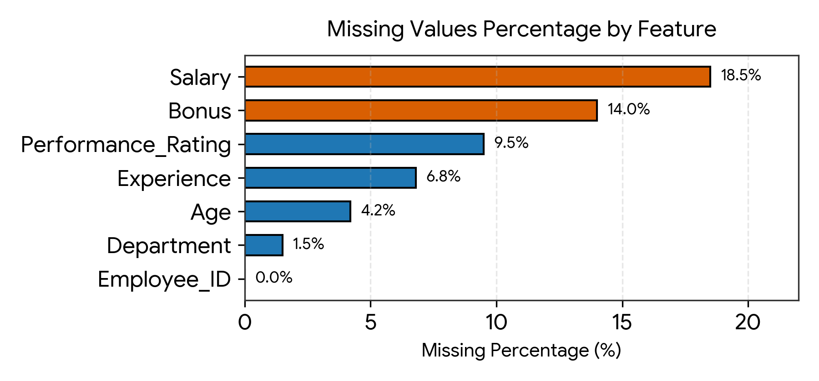
Figure 1. Horizontal bar chart showing missing-value percentages across dataset features.

Why values go missing (MCAR, MAR, MNAR)
Mechanism | Meaning | Practical Example
MCAR (Missing Completely at Random) | Missingness is unrelated to any observed or unobserved variable | A lab sensor randomly drops 2% of readings due to power spikes
MAR (Missing at Random) | Missingness depends on other observed variables, not the missing value itself | Younger employees are less likely to report Bonus, regardless of bonus size
MNAR (Missing Not at Random) | Missingness depends directly on the unobserved value itself | Very high earners intentionally leave the Salary field blank

Strategies for handling missing values
Strategy | When to Use | Advantage / Limitation
Drop rows (df.dropna()) | Missingness is tiny (< 2%) and MCAR | Simple, but loses sample size and may bias results
Drop column | Column has > 50–60% missing values with low signal | Prevents heavy fabrication, but discards potential information
Mean imputation | Numerical feature is approximately symmetric without outliers | Preserves sample mean, but reduces variance and distorts correlations
Median imputation | Numerical feature is skewed or contains outliers | Robust to extreme values; preferred default for skewed numeric data
Mode / Constant imputation | Categorical features | Fills with most frequent label or an explicit 'Missing' category
Group-wise imputation | Feature varies strongly by group (e.g., Salary by Department) | More accurate than global median; preserves group differences
Forward / Backward fill (ffill / bfill) | Ordered time-series data | Carries last known value forward; unsuitable for unordered rows
KNN / IterativeImputer | Multivariate patterns exist across features | Uses feature relationships to estimate values; higher computational cost

Cleaning duplicates, data types, and strings in Python
import pandas as pd
import numpy as np

# 1. Standardize hidden null markers upon loading
df = pd.read_csv("raw_employees.csv", na_values=["?", "NA", "N/A", "null", "-", ""])

# 2. Remove duplicate records based on unique identifier
df = df.drop_duplicates(subset=["Employee_ID"], keep="first").copy()

# 3. Clean string columns (strip whitespace, standardize case)
df["Department"] = df["Department"].astype(str).str.strip().str.upper()
df["Department"] = df["Department"].replace({"NAN": np.nan, "INFO TECH": "IT"})

# 4. Fix numeric columns stored as strings (e.g. "$65,000")
df["Salary"] = (
df["Salary"]
.astype(str)
.str.replace("$", "", regex=False)
.str.replace(",", "", regex=False)
)
df["Salary"] = pd.to_numeric(df["Salary"], errors="coerce")

# 5. Impute missing values
# Categorical: fill with mode
dept_mode = df["Department"].mode()[0]
df["Department"] = df["Department"].fillna(dept_mode)

# Numerical: group-wise median imputation (Salary by Department)
df["Salary"] = df["Salary"].fillna(
df.groupby("Department")["Salary"].transform("median")
)

# Fallback global median if an entire group was NaN
df["Salary"] = df["Salary"].fillna(df["Salary"].median())

4. Step 3: Outlier Detection & Treatment
An outlier is an observation that lies an abnormal distance from other values in a random sample. Outliers may arise from data-entry mistakes (e.g., age = 290), sensor glitches, or genuine extreme events (e.g., executive compensation). Always investigate the source of an outlier before removing or modifying it.
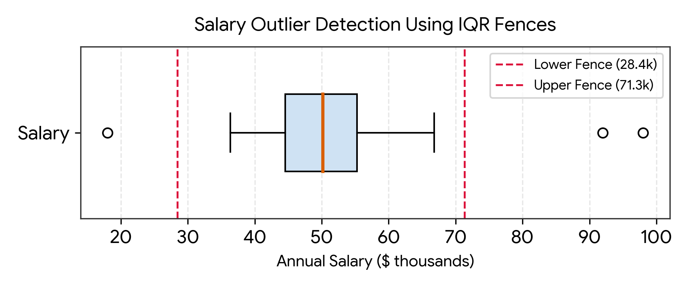
Figure 2. Box plot with Tukey's 1.5 × IQR lower and upper fences highlighting potential salary outliers.

Mathematical methods for outlier detection
Method | Rule / Formula | Best Suited For
IQR (Tukey's Fences) | LF = Q1 − 1.5 × IQR; UF = Q3 + 1.5 × IQR | Skewed or non-normal distributions (robust to extreme values)
Z-Score (Standard Score) | z = (x − μ) / σ; flag if |z| > 3.0 | Approximately normal (Gaussian) distributions
Modified Z-Score (MAD) | M_i = 0.6745 × |x_i − median| / MAD; flag if |M_i| > 3.5 | Small or heavily skewed datasets where mean/std are distorted
Percentile Capping (Winsorization) | Clip below 1st percentile or above 99th percentile | Automated production pipelines needing bounded inputs
Isolation Forest / DBSCAN | Multivariate tree-based or density-based anomaly scoring | High-dimensional datasets where outliers occur in combinations

Detecting and treating outliers in Python
import numpy as np
import pandas as pd

# Method 1: IQR Fence detection and Winsorization (capping)
Q1 = df["Salary"].quantile(0.25)
Q3 = df["Salary"].quantile(0.75)
IQR = Q3 - Q1

lower_fence = Q1 - 1.5 * IQR
upper_fence = Q3 + 1.5 * IQR

outliers_iqr = df[(df["Salary"] < lower_fence) | (df["Salary"] > upper_fence)]
print(f"Number of IQR outliers: {len(outliers_iqr)}")

# Cap (Winsorize) extreme values at the fences instead of dropping rows
df["Salary_Capped"] = df["Salary"].clip(lower=lower_fence, upper=upper_fence)

# Method 2: Z-Score detection
mean_sal = df["Salary"].mean()
std_sal = df["Salary"].std()
df["Salary_Z"] = (df["Salary"] - mean_sal) / std_sal

outliers_z = df[df["Salary_Z"].abs() > 3.0]
print(f"Number of Z-score outliers (|z| > 3): {len(outliers_z)}")

Important guideline: dropping outlier rows reduces sample size and can discard critical records (such as fraud cases or VIP customers). Capping (Winsorization) or applying a logarithmic transform often preserves row count while limiting undue influence on linear models.

5. Step 4: Analyzing Distributions & Skewness
Univariate distribution analysis examines the central tendency, dispersion, asymmetry (skewness), and tail heaviness (kurtosis) of each numerical feature. Many linear models and distance-based algorithms perform better when heavily skewed features are transformed toward symmetry.
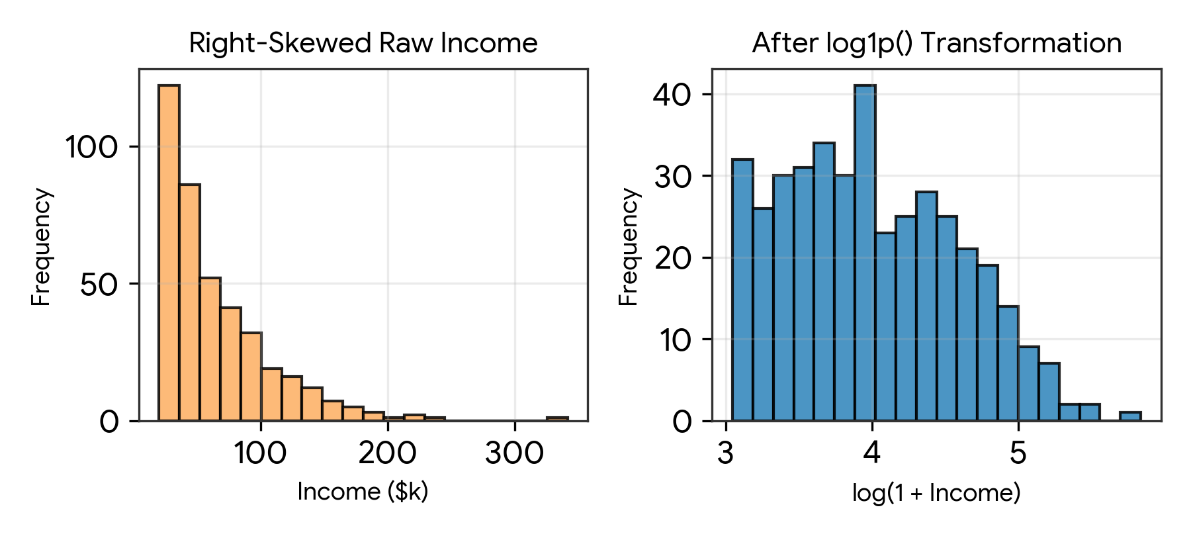
Figure 3. Comparison of a right-skewed income distribution before and after a log1p() transformation.

Interpreting skewness and kurtosis
Metric / Range | Distribution Shape | Relationship & Implication
Skewness ≈ 0 (−0.5 to +0.5) | Approximately symmetric | Mean ≈ Median ≈ Mode; standard normal assumptions hold well
Positive Skew (Skewness > +0.5) | Right-skewed (long right tail) | Mean > Median > Mode; common in income, house prices, web traffic
Negative Skew (Skewness < −0.5) | Left-skewed (long left tail) | Mean < Median < Mode; common in easy exam scores or age at retirement
Highly Skewed (|Skewness| > 1.0) | Strongly asymmetric | Consider log1p, square-root, Box-Cox, or Yeo-Johnson transformation
Kurtosis (Excess > 0, Leptokurtic) | Heavy tails and sharp peak | Higher probability of extreme outlier values than a normal distribution
Kurtosis (Excess < 0, Platykurtic) | Light tails and flatter peak | Fewer extreme observations than a normal distribution

Measuring skewness and applying transformations
import numpy as np
import pandas as pd
from scipy import stats

# Measure skewness and excess kurtosis
skew_val = df["Salary"].skew()
kurt_val = df["Salary"].kurt()
print(f"Skewness: {skew_val:.3f}, Excess Kurtosis: {kurt_val:.3f}")

# 1. Log transformation (use np.log1p to safely handle zero values: log(1 + x))
df["Salary_Log"] = np.log1p(df["Salary"])

# 2. Square-root transformation (for moderate right skew or count data)
df["Projects_Sqrt"] = np.sqrt(df["Projects_Completed"])

# 3. Box-Cox transformation (requires strictly positive values > 0)
df["Salary_BoxCox"], fitted_lambda = stats.boxcox(df["Salary"])

print("Skewness after log1p:", df["Salary_Log"].skew().round(3))

6. Step 5: Correlation & Multivariate Analysis
Bivariate and multivariate analysis explore how variables move together. Correlation quantifies the direction and strength of association between two numerical features, helping identify strong predictors for target variables as well as redundant (multicollinear) features.
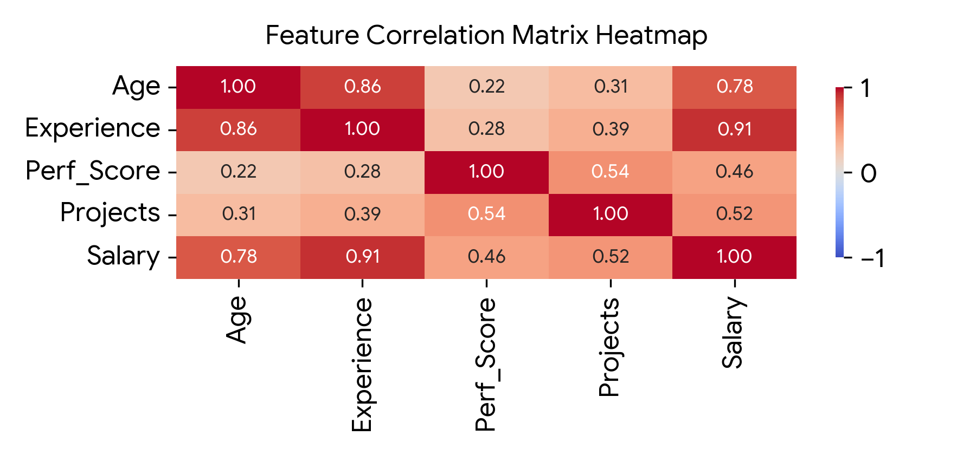
Figure 4. Annotated Pearson correlation matrix heatmap across five numerical employee attributes.

Comparing correlation and collinearity metrics
Metric | What It Measures | Key Rule of Thumb
Pearson r | Linear relationship between two continuous variables | Range [−1, +1]; sensitive to outliers and nonlinear curves
Spearman ρ (rho) | Monotonic relationship using ranked values | Range [−1, +1]; robust to outliers and skewed distributions
Point-Biserial / ANOVA | Association between a binary/categorical and numeric variable | Compare group means/medians across categories
Chi-Square / Cramér's V | Association between two categorical variables | Based on contingency tables (pd.crosstab)
Variance Inflation Factor (VIF) | Multicollinearity among predictor variables | VIF = 1 / (1 − R²); VIF > 5 (or 10) indicates severe multicollinearity

Correlation matrix, cross-tabulation, and group aggregation
import pandas as pd
import seaborn as sns
import matplotlib.pyplot as plt

# 1. Numerical correlation (Pearson and Spearman)
numeric_cols = df.select_dtypes(include="number").columns
pearson_corr = df[numeric_cols].corr(method="pearson")
spearman_corr = df[numeric_cols].corr(method="spearman")

plt.figure(figsize=(7, 5))
sns.heatmap(pearson_corr, annot=True, cmap="coolwarm", fmt=".2f", vmin=-1, vmax=1)
plt.title("Pearson Correlation Matrix")
plt.tight_layout()
plt.show()

# 2. Categorical vs Numerical: Groupby summary
dept_summary = df.groupby("Department").agg(
Count=("Employee_ID", "count"),
Mean_Salary=("Salary", "mean"),
Median_Salary=("Salary", "median"),
Avg_Experience=("Experience_Years", "mean")
)
print(dept_summary)

# 3. Categorical vs Categorical: Contingency table (Cross-tabulation)
ct = pd.crosstab(df["Department"], df["Education_Level"], normalize="index") * 100
print("\nEducation Level (%) within each Department:")
print(ct.round(1))

7. Step 6: Feature Creation & Categorical Encoding
Feature engineering uses domain knowledge to create new informative variables and convert non-numeric columns into numerical representations that machine learning models can process.

Common feature-creation techniques
Technique | Description | Example
Ratios & Interactions | Combine two or more numerical columns mathematically | Salary_per_Project = Salary / (Projects + 1)
Domain Aggregations | Compute row-level or group-level statistics | Total_Compensation = Salary + Bonus; Dept_Avg_Salary
Binning / Discretization | Convert continuous values into ordered intervals | Age → Junior (<28), Mid (28–40), Senior (>40) via pd.cut()
Datetime Extraction | Decompose timestamps into cyclical or calendar parts | Hire_Date → Hire_Year, Hire_Month, Day_of_Week, Tenure_Years
Missingness Indicator | Binary flag recording whether a value was originally null | Bonus_Was_Missing = df['Bonus'].isnull().astype(int)

Categorical encoding methods
Encoding Method | How It Works | When to Use & Caveats
Label / Ordinal Encoding | Maps each category to an integer (0, 1, 2, ...) | Use for ordinal variables (Low=0, Med=1, High=2); avoid on nominal features in linear models
One-Hot Encoding | Creates a binary (0/1) column for each category | Best for nominal features with low cardinality (< 10–15 unique categories)
Dummy Encoding (drop_first=True) | Creates k − 1 binary columns for k categories | Prevents the dummy variable trap (perfect multicollinearity) in linear regression
Frequency / Count Encoding | Replaces each category with its occurrence count or share | Useful for high-cardinality nominal features in tree-based models
Target Encoding | Replaces category with the mean of the target variable | Must be computed strictly on training folds to prevent severe target leakage

Feature creation and encoding in Python
import pandas as pd
import numpy as np

# 1. Create domain-specific numerical features
df["Total_Compensation"] = df["Salary"] + df["Bonus"]
df["Salary_per_Exp"] = df["Salary"] / (df["Experience_Years"] + 1)

# 2. Discretize Age into ordered bands using pd.cut()
df["Age_Group"] = pd.cut(
df["Age"],
bins=[18, 28, 40, 65],
labels=["Junior", "Mid_Level", "Senior"]
)

# 3. Ordinal encoding for ordered categories (Education_Level)
edu_mapping = {"BACHELORS": 1, "MASTERS": 2, "PHD": 3}
df["Education_Encoded"] = df["Education_Level"].map(edu_mapping)

# 4. One-Hot encoding for nominal categories (Department)
df_encoded = pd.get_dummies(
df,
columns=["Department"],
drop_first=True,
dtype=int
)

8. Step 7: Normalization & Standardization (Feature Scaling)
Numerical features often span wildly different magnitudes—for example, Age ranges from 21 to 60 while Salary ranges from 30,000 to 150,000. Without feature scaling, algorithms that rely on Euclidean distances or gradient descent treat Salary as thousands of times more important than Age.
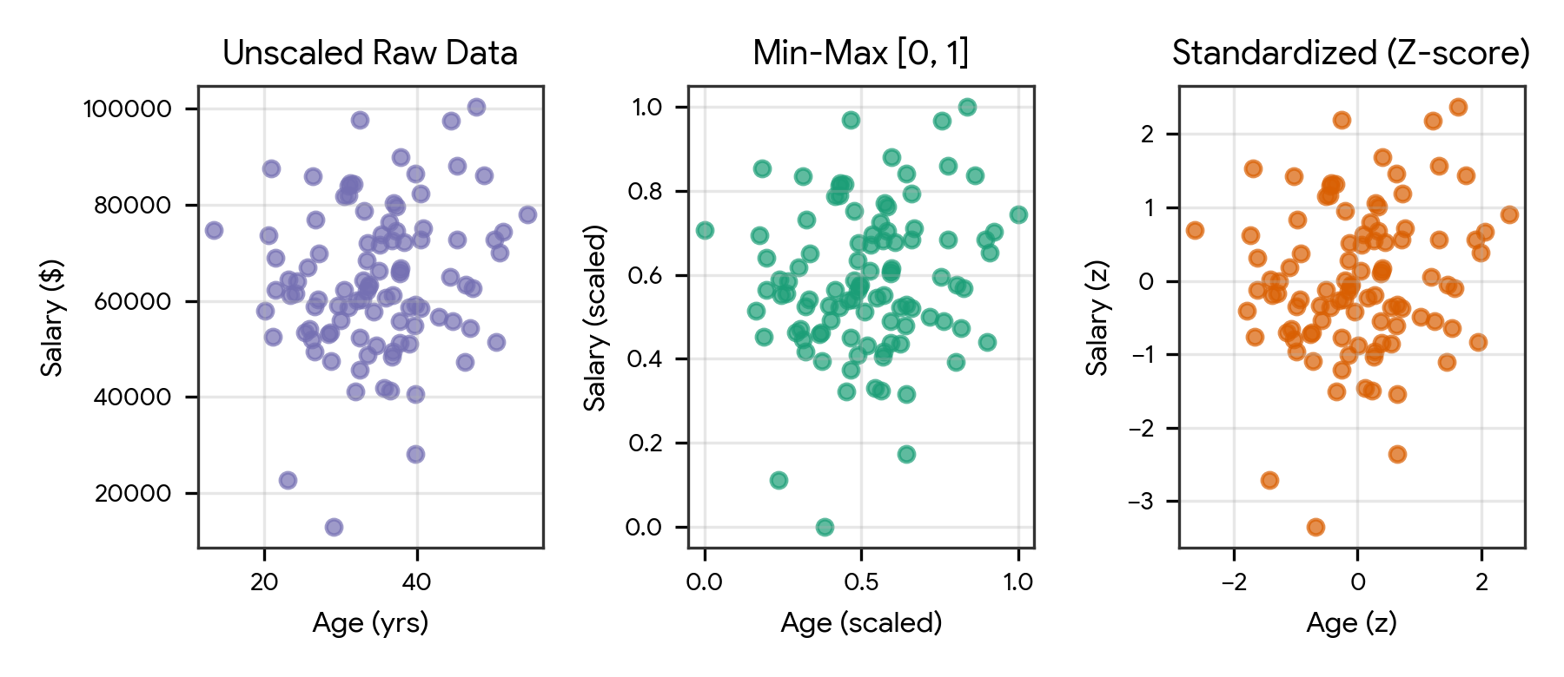
Figure 5. Visual comparison of unscaled raw features, Min-Max normalized features [0, 1], and Z-score standardized features.

Normalization vs Standardization vs Robust Scaling
Scaler | Mathematical Formula | Output Properties | Best Used When
Min-Max Normalization (MinMaxScaler) | x' = (x − x_min) / (x_max − x_min) | Bounded strictly to [0, 1] (or [a, b]) | Bounded inputs needed (Neural Networks, image pixels, KNN); sensitive to outliers
Z-Score Standardization (StandardScaler) | z = (x − μ) / σ | Mean = 0, Standard Deviation = 1 (unbounded) | Linear/Logistic Regression, SVM, PCA, K-Means; assumes rough symmetry
Robust Scaling (RobustScaler) | x' = (x − Median) / IQR | Centered at median = 0, scaled by IQR | Features contain outliers or heavy skew that distort mean and min/max

Which machine learning algorithms require scaling?
Algorithm Family | Requires Feature Scaling? | Reason
KNN, K-Means, Hierarchical Clustering, SVM (RBF) | Yes (Mandatory) | Directly compute Euclidean or Manhattan distances between feature vectors
Linear / Logistic Regression, Ridge, Lasso, ElasticNet | Yes (Strongly Recommended) | Regularization penalties (L1/L2) and gradient descent depend on feature scale
Principal Component Analysis (PCA), LDA | Yes (Mandatory) | Maximizes variance directions; unscaled high-magnitude features dominate components
Artificial Neural Networks / Deep Learning | Yes (Mandatory) | Stabilizes gradient descent backpropagation and prevents exploding gradients
Decision Trees, Random Forest, XGBoost, LightGBM | No (Scale-Invariant) | Split nodes using single-feature threshold comparisons; monotonic scaling does not change splits

Preventing data leakage during scaling and preprocessing
Critical rule: always split the dataset into training and testing sets before fitting any imputer, encoder, or scaler. Call fit_transform() on the training set to learn parameters (such as train mean and standard deviation), and call transform() on the test set using those exact training parameters.
from sklearn.model_selection import train_test_split
from sklearn.preprocessing import StandardScaler, MinMaxScaler, RobustScaler
import pandas as pd

features = ["Age", "Experience_Years", "Salary", "Total_Compensation"]
X = df[features]
y = df["Performance_Score"]

# 1. Split BEFORE fitting scalers to prevent data leakage
X_train, X_test, y_train, y_test = train_test_split(
X, y, test_size=0.2, random_state=42
)

# 2. Fit StandardScaler ONLY on X_train, then transform both X_train and X_test
std_scaler = StandardScaler()
X_train_std = pd.DataFrame(
std_scaler.fit_transform(X_train),
columns=features,
index=X_train.index
)
X_test_std = pd.DataFrame(
std_scaler.transform(X_test),
columns=features,
index=X_test.index
)

# 3. Alternative: Min-Max Normalization to [0, 1]
minmax_scaler = MinMaxScaler()
X_train_mm = pd.DataFrame(
minmax_scaler.fit_transform(X_train),
columns=features,
index=X_train.index
)

9. Choosing the Right Preprocessing Technique
Data Issue / Scenario | Recommended Technique | Reason
Numerical column with < 5% missing values and skew | Median imputation (global or group-wise) | Median resists distortion from extreme tail values
Categorical column with missing entries | Mode imputation or 'Missing' category | Preserves categorical type without inventing numeric values
Extreme numerical outliers from measurement noise | IQR Winsorization (clip to [LF, UF]) | Limits outlier leverage without losing entire rows
Strongly right-skewed positive feature (e.g. Income) | Log transformation: np.log1p(x) | Compresses long right tail toward a symmetric bell shape
Nominal categorical column (e.g. Department) | One-Hot Encoding (pd.get_dummies) | Avoids imposing artificial numerical ordering on categories
Ordinal categorical column (e.g. Low, Medium, High) | Ordinal / Map Encoding (0, 1, 2) | Preserves natural rank order in a single feature
Features have different units for SVM / KNN / PCA | StandardScaler (or RobustScaler if outliers exist) | Equalizes variance contribution across all dimensions
Features need strict [0, 1] bounds for Neural Nets | MinMaxScaler | Maps minimum to 0 and maximum to 1 cleanly

Quick decision guide
What preprocessing step is needed?
|
+-- Missing values?
| |-- Numeric & symmetric ---------> Mean imputation
| |-- Numeric & skewed/outliers ---> Median or group-median imputation
| +-- Categorical -----------------> Mode or 'Missing' label
|
+-- Outliers present?
| |-- Data entry error ------------> Correct or drop record
| |-- Valid extreme value ---------> Cap (Winsorize) at IQR fences or use RobustScaler
| +-- Heavy positive skew ---------> Apply np.log1p() transformation
|
+-- Categorical column?
| |-- Ordered (Ordinal) -----------> Ordinal / Label mapping (1, 2, 3)
| +-- Unordered (Nominal) ---------> One-Hot Encoding (drop_first=True)
|
+-- Scaling numerical features?
|-- Bounded [0, 1] required -----> MinMaxScaler
|-- Zero mean, unit variance ----> StandardScaler
+-- Outliers still present ------> RobustScaler

10. Practical Project — End-to-End Employee EDA & Preprocessing Pipeline
Objective: build a modular, production-style Python pipeline that loads raw employee records, inspects data quality, cleans duplicates and missing values, detects and caps IQR outliers, analyzes distributions and correlations, creates engineered features, applies both Min-Max normalization and Z-score standardization, and exports clean datasets and visual diagnostic reports.

Project structure
eda_preprocessing_project/
|
|-- data/
| |-- raw_employees.csv
|
|-- outputs/
|
|-- main.py
|-- requirements.txt

requirements.txt
pandas
numpy
matplotlib
seaborn
scikit-learn
scipy

Sample data — data/raw_employees.csv
Employee_ID,Name,Department,Education,Age,Experience_Years,Projects,Performance_Score,Salary,Bonus
101,Aman,CSE,Masters,26,3,5,82,55000,5000
102,Rahul,AI,PhD,31,7,9,91,88000,11000
103,Simran,CSE,Bachelors,24,2,3,76,46000,3500
104,Harshit,AI,Masters,29,5,8,88,75000,8500
105,Neha,IT,Bachelors,27,4,4,79,52000,
106,Karan,IT,Bachelors,35,10,11,84,78000,7200
107,Priya,CSE,Masters,28,,6,86,64000,6000
108,Arjun,AI,PhD,42,16,15,95,185000,25000
109,Riya,IT,Masters,30,6,7,85,,6800
110,Manav,CSE,Bachelors,23,1,2,72,42000,2500
102,Rahul,AI,PhD,31,7,9,91,88000,11000
111,Kavya,AI,Masters,27,4,7,87,69000,7400
112,Vikram,IT,Bachelors,25,2,3,74,45000,3100

Complete main.py
import os
import numpy as np
import pandas as pd
import matplotlib.pyplot as plt
import seaborn as sns
from sklearn.preprocessing import StandardScaler, MinMaxScaler

class EDAPreprocessingPipeline:
def __init__(self, file_path):
self.file_path = file_path
self.data = None
self.output_dir = "outputs"
self.numeric_cols = [
"Age",
"Experience_Years",
"Projects",
"Performance_Score",
"Salary",
"Bonus"
]
os.makedirs(self.output_dir, exist_ok=True)
sns.set_theme(style="whitegrid")

def load_and_understand(self):
try:
self.data = pd.read_csv(self.file_path)
print("=== STEP 1: DATASET UNDERSTANDING ===")
print(f"Initial Shape: {self.data.shape}")
print("\nColumn Data Types & Non-Null Counts:")
print(self.data.info())
print("\nMissing Values Count:")
print(self.data.isnull().sum())
print("\nDuplicate Rows:", self.data.duplicated().sum())
except FileNotFoundError:
print("Error: Input CSV file not found.")

def clean_data(self):
print("\n=== STEP 2: DATA CLEANING ===")
before_rows = len(self.data)
self.data = self.data.drop_duplicates(subset=["Employee_ID"], keep="first").copy()
print(f"Removed {before_rows - len(self.data)} duplicate row(s).")

# Standardize categorical strings
for col in ["Department", "Education"]:
self.data[col] = self.data[col].astype(str).str.strip()
mode_val = self.data[col].mode()[0]
self.data[col] = self.data[col].replace("nan", mode_val).fillna(mode_val)

# Convert numeric columns and impute missing values with group/global median
for col in self.numeric_cols:
self.data[col] = pd.to_numeric(self.data[col], errors="coerce")
self.data[col] = self.data[col].fillna(
self.data.groupby("Department")[col].transform("median")
)
self.data[col] = self.data[col].fillna(self.data[col].median())

print("Remaining missing values:", self.data.isnull().sum().sum())

def detect_and_treat_outliers(self):
print("\n=== STEP 3: OUTLIER DETECTION & TREATMENT (IQR) ===")
for col in ["Salary", "Bonus"]:
q1 = self.data[col].quantile(0.25)
q3 = self.data[col].quantile(0.75)
iqr = q3 - q1
lower_fence = q1 - 1.5 * iqr
upper_fence = q3 + 1.5 * iqr

outlier_mask = (self.data[col] < lower_fence) | (self.data[col] > upper_fence)
print(
f"{col}: Q1={q1:.1f}, Q3={q3:.1f}, IQR={iqr:.1f}, "
f"Fences=[{lower_fence:.1f}, {upper_fence:.1f}], "
f"Outliers={outlier_mask.sum()}"
)
self.data[f"{col}_Capped"] = self.data[col].clip(lower_fence, upper_fence)

plt.figure(figsize=(8, 4))
sns.boxplot(data=self.data[["Salary", "Salary_Capped"]], orient="h")
plt.title("Salary Before vs After IQR Capping")
plt.tight_layout()
plt.savefig(os.path.join(self.output_dir, "outlier_capping.png"), dpi=300)
plt.close()

def analyze_distributions(self):
print("\n=== STEP 4: DISTRIBUTION & SKEWNESS ANALYSIS ===")
for col in self.numeric_cols:
print(f"{col:18s} -> Skewness: {self.data[col].skew():+.3f}")

self.data["Salary_Log"] = np.log1p(self.data["Salary_Capped"])

fig, axes = plt.subplots(1, 2, figsize=(10, 4))
sns.histplot(self.data["Salary_Capped"], kde=True, ax=axes[0], color="steelblue")
axes[0].set_title("Capped Salary Distribution")
sns.histplot(self.data["Salary_Log"], kde=True, ax=axes[1], color="darkorange")
axes[1].set_title("Log-Transformed Salary Distribution")
fig.tight_layout()
fig.savefig(os.path.join(self.output_dir, "distribution_analysis.png"), dpi=300)
plt.close(fig)

def analyze_correlations(self):
print("\n=== STEP 5: CORRELATION ANALYSIS ===")
corr = self.data[self.numeric_cols].corr()
print(corr.round(2))

plt.figure(figsize=(8, 6))
sns.heatmap(corr, annot=True, cmap="coolwarm", fmt=".2f", vmin=-1, vmax=1)
plt.title("Feature Correlation Matrix")
plt.tight_layout()
plt.savefig(os.path.join(self.output_dir, "correlation_matrix.png"), dpi=300)
plt.close()

def engineer_features(self):
print("\n=== STEP 6: FEATURE CREATION & ENCODING ===")
self.data["Total_Comp"] = self.data["Salary_Capped"] + self.data["Bonus_Capped"]
self.data["Salary_per_Exp"] = (
self.data["Salary_Capped"] / (self.data["Experience_Years"] + 1)
)
self.data["Projects_per_Year"] = (
self.data["Projects"] / (self.data["Experience_Years"] + 1)
)

edu_order = {"Bachelors": 1, "Masters": 2, "PhD": 3}
self.data["Education_Ord"] = self.data["Education"].map(edu_order)

self.data = pd.get_dummies(
self.data,
columns=["Department"],
prefix="Dept",
drop_first=True,
dtype=int
)
print("Engineered columns added. New shape:", self.data.shape)

def scale_features(self):
print("\n=== STEP 7: NORMALIZATION & STANDARDIZATION ===")
scale_cols = [
"Age",
"Experience_Years",
"Projects",
"Performance_Score",
"Salary_Capped",
"Total_Comp"
]

minmax = MinMaxScaler()
std = StandardScaler()

mm_values = minmax.fit_transform(self.data[scale_cols])
std_values = std.fit_transform(self.data[scale_cols])

for idx, col in enumerate(scale_cols):
self.data[f"{col}_MinMax"] = mm_values[:, idx].round(4)
self.data[f"{col}_ZScore"] = std_values[:, idx].round(4)

out_csv = os.path.join(self.output_dir, "preprocessed_employees.csv")
self.data.to_csv(out_csv, index=False)
print(f"Preprocessed dataset saved to: {out_csv}")

def run(self):
self.load_and_understand()
if self.data is None:
return
self.clean_data()
self.detect_and_treat_outliers()
self.analyze_distributions()
self.analyze_correlations()
self.engineer_features()
self.scale_features()
print("\nComplete EDA & preprocessing workflow finished successfully.")

if __name__ == "__main__":
pipeline = EDAPreprocessingPipeline("data/raw_employees.csv")
pipeline.run()

Run the project
pip install -r requirements.txt
python main.py

Expected generated outputs
outputs/
|-- outlier_capping.png
|-- distribution_analysis.png
|-- correlation_matrix.png
|-- preprocessed_employees.csv

Project notes: in a supervised machine learning workflow where a target label is predicted on unseen data, always split the dataset into training and testing sets prior to group imputation, outlier fence calculation, and feature scaling so that test distribution statistics never leak into training.

11. Common Mistakes to Avoid
- Fitting scalers, imputers, or target encoders on the entire dataset before splitting into train and test sets (causes data leakage).
- Replacing missing values with zero or an arbitrary number like −999 before feeding features into linear or distance-based models.
- Using the arithmetic mean to impute missing values in a heavily skewed column where the median is much more representative.
- Automatically deleting every flagged IQR or Z-score outlier without checking whether it represents valid domain behavior.
- Applying LabelEncoder or arbitrary integer codes to unordered nominal categories (e.g., CSE=1, IT=2, HR=3) in linear regression or KNN.
- Applying np.log(x) directly to a column containing zeros or negative values instead of using np.log1p(x) or Yeo-Johnson.
- Retaining two nearly identical collinear features (e.g., Salary in USD and Salary in INR, r = 1.0) in linear models.
- Scaling categorical one-hot binary columns or tree-only datasets unnecessarily when interpretability of raw thresholds matters.
- Forgetting to reset or align DataFrame indices when concatenating scaled NumPy arrays back with existing Pandas columns.

12. Quick Revision — Key Differences
Comparison | First Concept | Second Concept
Mean vs Median Imputation | Uses arithmetic average; sensitive to outliers | Uses 50th percentile; robust to skewness and outliers
IQR Method vs Z-Score Method | Uses quartiles (Q1, Q3); works on skewed data | Uses mean and std; assumes roughly normal distribution
Trimming vs Winsorization (Capping) | Drops outlier rows from the dataset | Clips outlier values to the lower/upper fence thresholds
Pearson vs Spearman Correlation | Measures linear relationship on raw values | Measures monotonic relationship on ranked values
Ordinal Encoding vs One-Hot Encoding | Maps categories to 1 column of ordered integers | Creates binary (0/1) indicator columns for each category
Normalization (Min-Max) vs Standardization | Rescales values into a bounded range [0, 1] | Centers values at mean 0 with standard deviation 1
fit_transform() vs transform() | Learns parameters AND transforms training data | Applies already-learned training parameters to test data

13. Important Formulas
Concept | Formula / Definition
Sample Mean | x̄ = (1 / n) × Σ x_i
Sample Standard Deviation | s = sqrt( [1 / (n − 1)] × Σ (x_i − x̄)² )
Interquartile Range (IQR) | IQR = Q3 − Q1 (75th percentile − 25th percentile)
Tukey's Outlier Fences | Lower Fence = Q1 − 1.5 × IQR; Upper Fence = Q3 + 1.5 × IQR
Z-Score (Standardization) | z = (x − μ) / σ
Min-Max Normalization | x_norm = (x − x_min) / (x_max − x_min)
Robust Scaling | x_robust = (x − Median) / IQR
Sample Skewness | g_1 = [ (1 / n) Σ (x_i − x̄)³ ] / s³
Log1p Transformation | y = ln(1 + x) (defined for x ≥ 0)
Pearson Correlation (r) | r = Cov(X, Y) / (σ_X × σ_Y)
Variance Inflation Factor (VIF) | VIF_j = 1 / (1 − R_j²)

Rule of thumb summary: flag Z-scores when |z| > 3.0; consider a feature strongly skewed when |skewness| > 1.0; investigate multicollinearity when |r| > 0.85 or VIF > 5.0.

14. Interview / Viva Questions
What is Exploratory Data Analysis (EDA)?
A systematic approach to inspecting, cleaning, summarizing, and visualizing datasets to uncover structure, anomalies, and variable relationships before modeling.
Why is data preprocessing necessary before machine learning?
Raw data contains missing values, duplicates, text labels, outliers, and mismatched numerical scales that cause algorithms to fail or learn biased patterns.
When should you prefer median imputation over mean imputation?
When the numerical feature is skewed or contains outliers, because extreme values pull the mean away from the typical central value.
What are MCAR, MAR, and MNAR?
Three mechanisms of missing data: Missing Completely at Random, Missing at Random (depends on observed columns), and Missing Not at Random (depends on the missing value itself).
How do you detect outliers using the IQR method?
Calculate IQR = Q3 − Q1 and flag any observation below Q1 − 1.5 × IQR or above Q3 + 1.5 × IQR.
What is Winsorization?
Capping extreme values at specified percentile or IQR fence thresholds rather than deleting the outlier rows.
What is skewness and how does it affect mean and median?
Skewness measures distribution asymmetry. In a right-skewed distribution, the mean is greater than the median; in a left-skewed distribution, the mean is less than the median.
Why do we use np.log1p(x) instead of np.log(x)?
Because log(0) is undefined (−infinity), whereas log1p(x) computes log(1 + x), which maps 0 cleanly to 0.
What is the difference between Pearson and Spearman correlation?
Pearson measures linear association using raw numeric values, while Spearman measures monotonic association using rank-ordered values.
What is multicollinearity and how is it detected?
Multicollinearity occurs when two or more predictor variables are highly correlated with each other. It is detected using correlation heatmaps (|r| > 0.85) or Variance Inflation Factor (VIF > 5).
What is the dummy variable trap?
Perfect multicollinearity created when all k one-hot encoded columns are included alongside an intercept term. Dropping one category (drop_first=True) resolves it.
When should you use Ordinal Encoding vs One-Hot Encoding?
Use Ordinal Encoding when categories have a natural rank (e.g., Small, Medium, Large) and One-Hot Encoding when categories have no intrinsic order (e.g., Red, Blue, Green).
What is the difference between Normalization and Standardization?
Normalization (Min-Max scaling) rescales values into a fixed interval like [0, 1], whereas Standardization (Z-score scaling) centers data to mean 0 and standard deviation 1.
Which machine learning algorithms are sensitive to feature scaling?
Distance-based and gradient-based algorithms such as KNN, K-Means, SVM, PCA, Linear/Logistic Regression with regularization, and Neural Networks.
Do Decision Trees and Random Forests require feature scaling?
No. Tree-based algorithms partition data using threshold splits on single features, which are invariant to monotonic rescaling.
When should you use RobustScaler?
When scaling numerical features that still contain outliers or heavy skewness, because RobustScaler uses the median and IQR instead of the mean and standard deviation.
What is data leakage in preprocessing?
Using information from the test set (such as global mean, min/max, or target averages) during training data preparation, leading to overly optimistic validation scores.
Why do we call fit_transform() on X_train but only transform() on X_test?
To ensure the test set is scaled using the exact statistical parameters learned from the training set, simulating unseen future data.
What does pd.cut() do in feature engineering?
It segments and sorts continuous numerical values into discrete intervals or bins (such as converting continuous age into age brackets).
How do you handle a numeric column that Pandas loaded as an object dtype?
Strip formatting characters (like '$' or ','), then call pd.to_numeric(df['col'], errors='coerce') to convert valid strings to numbers and invalid strings to NaN.

15. Coding Practice
- Load a CSV dataset and write a function that prints shape, column data types, duplicate row count, and missing value percentage per column.
- Clean a corrupted Salary column containing strings like '$54,000', '62,500', and '?' into a clean float64 Series.
- Impute missing numerical values in an employee dataset using department-level median values.
- Write a Python function that computes Q1, Q3, IQR, lower fence, and upper fence for any numeric Series and returns all outlier rows.
- Compare the mean and standard deviation of a feature before and after capping outliers at the 1.5 × IQR fences.
- Generate 500 right-skewed observations using np.random.exponential(), compute skewness, apply np.log1p(), and plot side-by-side histograms.
- Compute both Pearson and Spearman correlation matrices on a DataFrame and plot an annotated Seaborn heatmap.
- Create three engineered features from an e-commerce dataset: Total_Spend, Avg_Order_Value, and Customer_Tenure_Days.
- Use pd.cut() to bin an Age column into 'Youth', 'Adult', and 'Senior', then compute average salary per age group.
- Apply Ordinal mapping to an Education column and One-Hot encoding (with drop_first=True) to a Department column.
- Split a dataset into train and test sets and compare MinMaxScaler, StandardScaler, and RobustScaler outputs on the training features.
- Extend the Employee EDA pipeline to export a summary CSV comparing each numeric column's mean, median, IQR, and skewness before and after cleaning.

16. Day 387 Completion Checklist
- ☐ Understand the end-to-end EDA and data preprocessing workflow.
- ☐ Inspect dataset shape, types, non-null counts, duplicates and summary statistics.
- ☐ Distinguish between MCAR, MAR, and MNAR missing-data mechanisms.
- ☐ Impute missing values using mean, median, mode, and group-wise aggregations.
- ☐ Detect outliers using Tukey's 1.5 × IQR fences and Z-scores.
- ☐ Treat outliers appropriately using Winsorization (capping) or log transformations.
- ☐ Analyze univariate distributions, skewness, kurtosis, and power transforms.
- ☐ Compute Pearson and Spearman correlations and interpret heatmaps and multicollinearity.
- ☐ Engineer domain features including ratios, totals, and discretized bins.
- ☐ Encode nominal and ordinal categorical features using One-Hot and Ordinal encoding.
- ☐ Apply MinMaxScaler, StandardScaler, and RobustScaler without train-test data leakage.
- ☐ Build and run the End-to-End Employee EDA & Preprocessing Pipeline project.
- ☐ Complete all coding practice exercises and interview/viva questions.

17. Learning Outcomes
After completing this revision, you should be able to:
- Perform a structured exploratory data analysis on any raw tabular CSV dataset.
- Diagnose and repair missing values, duplicate rows, and corrupted data types.
- Quantify, visualize, and treat extreme outliers using IQR fences and Z-scores.
- Measure distribution skewness and apply log or Box-Cox transformations.
- Evaluate bivariate relationships and detect multicollinearity across predictors.
- Create domain-specific features and encode categorical variables for machine learning.
- Normalize and standardize numerical features cleanly without introducing data leakage.
Next recommended topic: Day 388 — Feature Selection, Dimensionality Reduction & Scikit-Learn Pipelines (Filter/Wrapper/Embedded methods, ColumnTransformer, Pipeline, and Cross-Validation).

